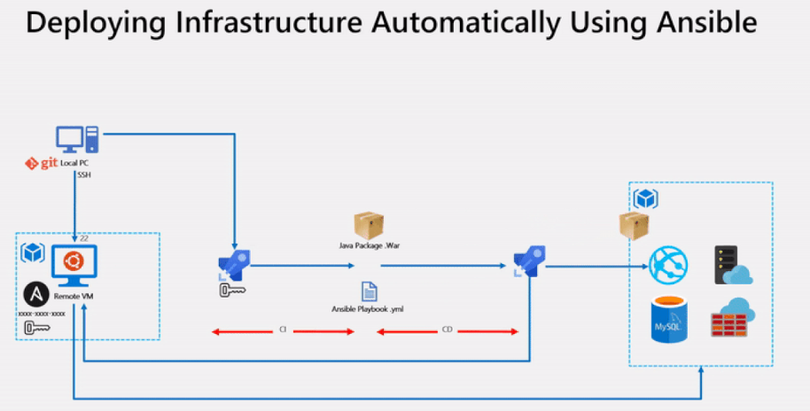

**Let’s consider we have a maven code in azure repo and want to deploy it in webapp on azure. Tasks involved are:**

**Creating SP**

**Configure Ansible in a Linux machine**

**Create an SSH Service Connection in Azure DevOps**

**Creating Azure CI pipeline**

**Creating Azure CD pipeline for deploying resources**

**Task1: Creating SP**

1. Login to cloud shell and use bash.
2. Create a service principal account

az ad sp create-for-rbac --name <ServicePrincipalName> (<ServicePrincipalName>: name of SPN)

1. It will give you a JSON output as shown in the image. Copy the output to notepad. This details required in your next tasks.
2. Enter the following command to get Azure SubscriptionID and copy the same to notepad.

az account show

**Task2: Configure Ansible in a Linux machine**

1. Login to your linux box.
2. Run below commands to install ansible on the machine:

$ apt update

$ apt install python-pip

$ pip install 'ansible[azure]'

1. Now we must create a directory named **.azure** in the home directory and a credentials file under it. Type the following commands to create them.

mkdir ~/.azure

nano ~/.azure/credentials

1. copy the below lines into your credentials file:

[default]

subscription_id=<your-Azure-subscription_id>

client_id=<azure service-principal-appid>

secret=<azure service-principal-password>

tenant=<azure serviceprincipal-tenant>

1. Ansible is an agentless architecture-based automation tool. Only it needs ssh authentication using Ansible Control Machine private/public key pair.
2. Let’s generate a private/public key pair for ssh and install the public key in the local machine.

ssh-keygen -t rsa

chmod 755 ~/.ssh

touch ~/.ssh/authorized_keys

chmod 644 ~/.ssh/authorized_keys

ssh-copy-id vmadmin@127.0.0.1

1. NOTE: Replace vmadmin with your VM username in the above command.

**Task3: Create an SSH Service Connection in Azure DevOps**

1. Generate SSH private key using below command and copy the private key to notepad.

cat ~/.ssh/id_rsa

1. Open Azure devops Navigate to Project Settings –> Service Connections. Select +New service connection and select SSH
2. Fill in the below field's:

Connection Name: <connection name for reference>

Hostname: <public IP of anisble vm>

Port number: 22

Username: <username of ansible vm>

Password: <password of ansible vm>

Private key: <stored in earlier step>

**Task4: Creating Azure CI pipeline**

1. Go to **Pipeline > Create New Pipeline> Use the classic editor (at the bottom of the page)**
2. **Select the repo and project then click on continue.**
3. **Now select maven in select a template section and press apply**

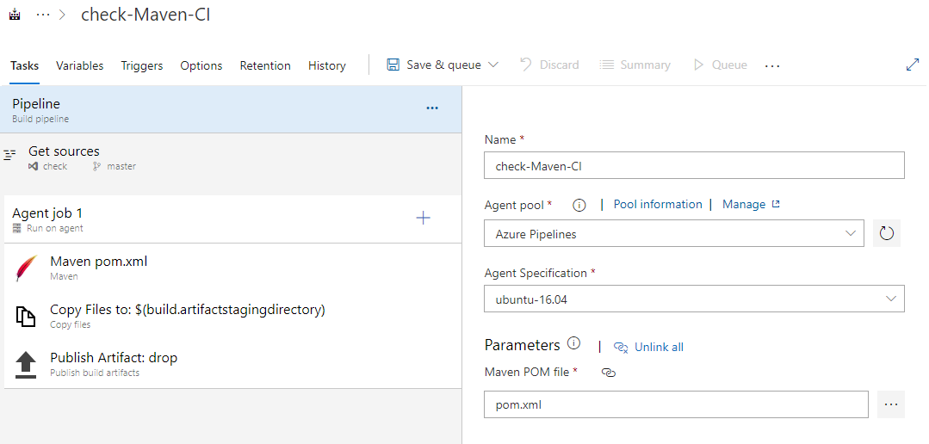

1. **In addition to the application build, we need to publish Ansible scripts so that it will be available in CD pipeline. So, we configured Copy files task to copy Ansible playbook .yml and the java web package .war file to Artifacts directory.**

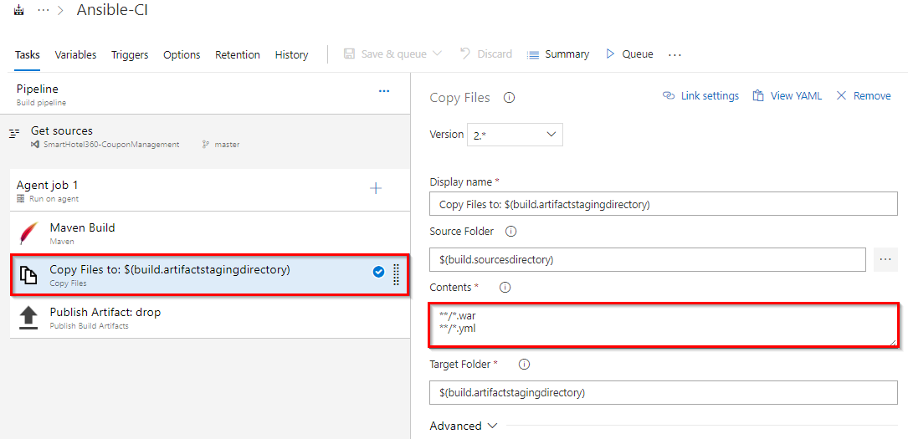

**Task5: Creating Azure CD pipeline for deploying resources**

1. Now Create deployment (CD) for the builds (CI)
2. Go to deployement and create a realease and align three tasks for the same as below

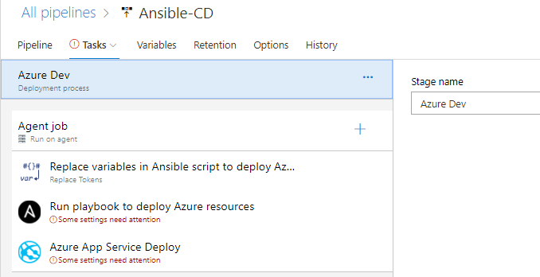

1. On the task select Replace Task and fill below values:

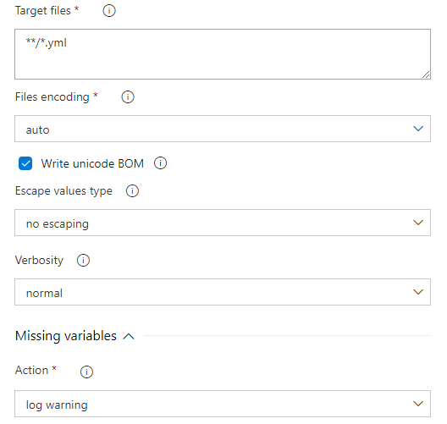

1. If you observe the **webapp.yml** file you will see there are few values are suffixed and prefixed with **__.**

For example:  **__** **webappName** **__**

1. Using Replace tokens task we will replace those values with the variable values defined in the release pipeline.

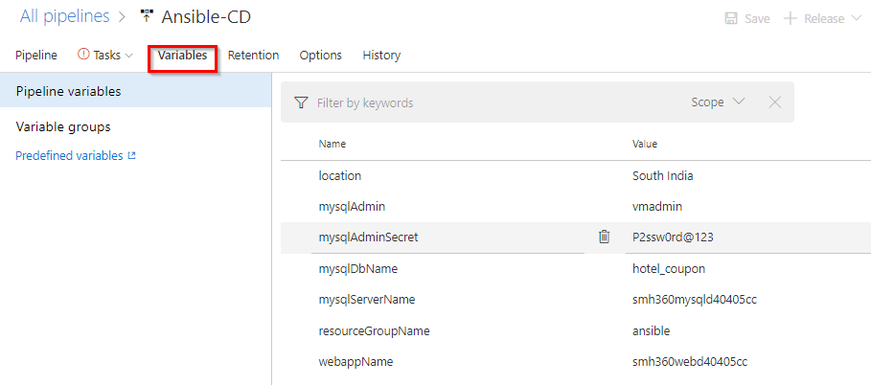

1. Create one more task for automating the infra creation. In tasks select ansible, this task is to integrate with Ansible. This task executes a given Ansible playbook on a specified list of inventory nodes via command line interface. This task requires that the Playbook files be located either on a private Linux agent or on a remote machine where Ansible automation engine has been installed. Select Ansible Location as **Remote Machine** and select VM name created earlier.

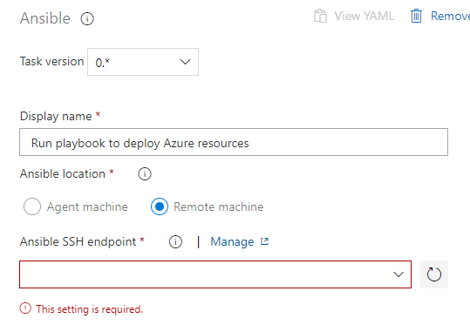

1. Now in playbook settings fill below details as the builds are hosted on the agent VM we are providing the same below. Where webapp.yml is name of file for creating written in ansible for automating infra.

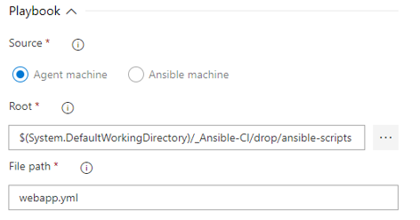

1. Under the **Inventory** section, select **Host list** as inventory location and enter pubic ip of your ansible VM in **Host list** field as shown below.

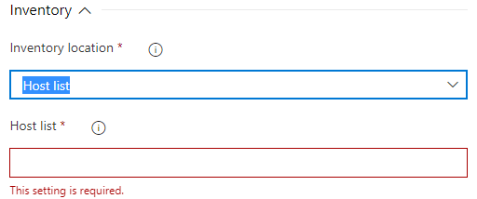

1. Now create the third task for deploying the code to webapp. In task select Azure App Service deploy. Select the Azure subscription from the drop-down list and click **Authorize** to configure Azure service connection. And this application requires few app settings to connect to the MySQL database provisioned using Ansible script. That we are updating using **App settings** parameter in the task. This task will deploy the SmartHotel360-CouponManagement package to Azure app service which is provisioned by Ansible task in previous step.

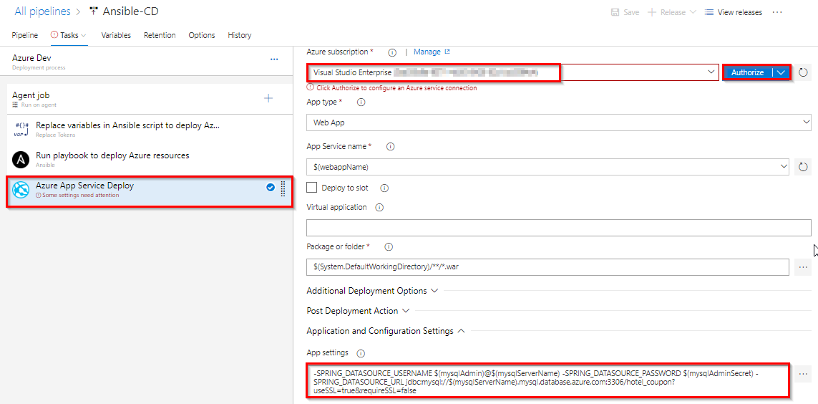

1. Once you are done **Save** the changes and **Create a release**.